-----------------------------

**Project Proposal on**

# Sensor Based Shopping Assistance for PwDs

Submitted by

**Bharath Kumar N 21BIT064 Naveen V C 21BIT074**

**Dinesh M 22BIT320**

**&**

**Guided by**

**Mr.Dhyaneswaran J**

**Assistant Professor Department of IT**

**Under the scheme of**

**Naan Mudhalvan – Anna University Niral Thiruvizha – Hackathon**

# TAMIL NADU SKILL DEVELOPMENT CORPERATION

**February 2025**

PROJECT PROPOSAL

1. **Major Area**

#### Information/Communication Technology.

#### Problem Statement

How might we create an advanced agricultural bot with multi-language support and animation that helps small-scale farmers with soil testing, pest detection, crop management, irrigation, and harvesting, while providing information on local government financial aids, farming schemes, and subsidies? The goal is to improve productivity, income, and food security, ultimately doubling agricultural output.

## College Code & College Name:

7276- Dr. Mahalingam College of Engineering and Technology, Pollachi

1. **Guide Name, Designation, Mobile No. & Email id**

Mr. Dhyaneswaran J

### Assistant Professor (SS), Department of IT,

Mob: 9043481758

Email: [dhyan123@drmcet.ac.in](mailto:dhyan123@drmcet.ac.in)

#### Student Team details

|  |  |  |  |  |  |
| --- | --- | --- | --- | --- | --- |
| SI.NO | Student  Reg.  No | Name of the  Student | Branch | Mobile No. | Email id |
| 1 | 21BIT064 | BHARATH KUMAR N | IT | 8903906588 | [bharathkumar08092003@gmail.com](mailto:bharathkumar08092003@gmail.com)  [727621bit064@mcet.in](mailto:727621bit064@mcet.in) |
| 2 | 21BIT074 | NAVEEN V C | IT | 7010582553 | [naveennav33n@gmail.com](mailto:naveennav33n@gmail.com)  [727621bit074@mcet.in](mailto:727621bit074@mcet.in) |
| 3 | 22BIT320 | DINESH M | IT | 8940458185 | mylandinesh[@gmail.com](mailto:ajaykrishnathirumalai@gmail.com)  [727622bit320@mcet.in](mailto:727622bit320@mcet.in) |

1. **Project Summary:**

Access to modern agricultural resources remains a significant challenge for small-scale farmers, especially those in remote or underserved regions. These farmers often struggle with issues like poor soil management, inefficient irrigation, pest and disease control, and lack of timely information on best farming practices and government schemes. Additionally, the absence of proper technology integration limits their ability to improve productivity and income, further exacerbating food insecurity in these areas. Small-scale farmers are also often unaware of government subsidies, agricultural schemes, and modern farming techniques, which restrict their access to opportunities that could significantly improve their livelihood.

The proposed project aims to address these challenges by developing an **advanced agricultural bot** designed to provide a comprehensive solution for small-scale farmers. This bot will leverage cutting-edge technologies such as **computer vision**, **machine learning**, **natural language processing (NLP)**, and **IoT** to assist farmers with key aspects of farming like **soil testing**, **pest detection**, **crop management**, **irrigation**, and **harvesting**. Additionally, it will offer vital information on **government schemes**, **financial aids**, and **subsidies** to ensure farmers are fully informed and can maximize available resources.

By offering **multi-language support**, the bot will cater to diverse linguistic needs across rural regions, making it accessible for farmers who may not speak English. It will guide farmers through soil testing processes, helping them understand the health of their land and make informed decisions about fertilizers and soil care. The bot will also use **image recognition** and AI to detect pests and diseases in crops, allowing for real-time alerts and recommendations for pest management.

With **real-time weather data** and **IoT sensors**, the bot will optimize irrigation schedules to conserve water and reduce wastage, ensuring that crops receive just the right amount of moisture. Furthermore, the bot will provide valuable insights into the best time to harvest crops based on **AI-driven algorithms**, improving crop yield and quality.

In addition to these features, the agricultural bot will be integrated with **local government databases**, providing farmers with easy access to subsidies, farming schemes, and financial aid programs, which are often difficult to navigate. The bot will serve as a digital bridge, connecting farmers to a wealth of resources and opportunities that can enhance their farming practices and improve their financial situation.

In summary, the **advanced agricultural bot** will empower small-scale farmers by providing them with essential tools, real-time insights, and access to government support. By harnessing **AI** and **IoT technologies**, this bot will improve **productivity**, **income**, and **food security**, ultimately contributing to sustainable agricultural practices and enhancing the overall livelihood of farmers.

1. **Proposed solution with methodology**

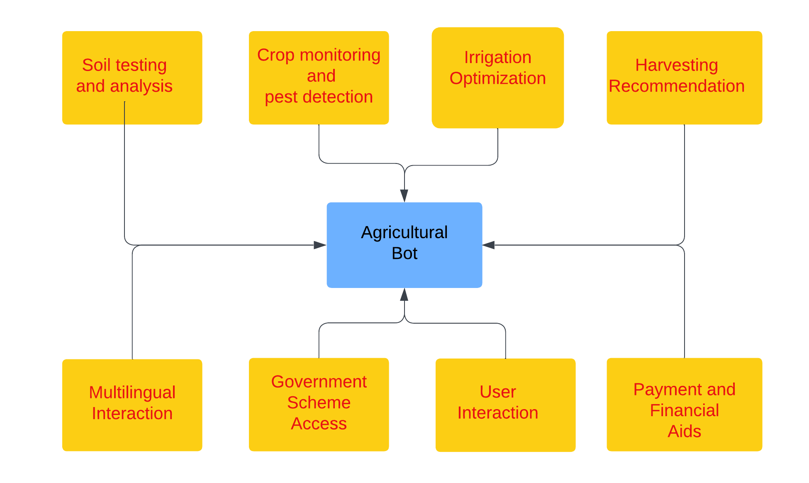

*Figure 1. Process flow/Methodology of proposed solution*

Access to modern agricultural resources remains a significant challenge for small-scale farmers, especially in remote and underserved regions. These farmers often face issues such as poor soil management, inefficient irrigation, pest and disease control, and lack of timely information on best farming practices and government schemes. The absence of proper technology integration limits their productivity and income, worsening food insecurity. To address these challenges, we propose an **Integrated Agricultural Support System (IASS)**, leveraging advanced technologies to empower farmers and enhance agricultural efficiency.

**Methodology**

**Soil Testing and Analysis**

* **IoT Sensors Integration**: Deploy IoT-based soil sensors to measure soil parameters like pH, moisture, temperature, and nutrient content.
* **Data Processing**: Use machine learning algorithms to analyze collected soil data and provide personalized recommendations for fertilizers and soil treatment.
* **Mobile App Interface**: Develop a user-friendly interface where farmers can access soil reports and actionable insights.

**Crop Monitoring and Pest Detection**

* **Camera with Computer Vision**: Utilize a camera integrated with the bot to capture images of crops.
* **Image Recognition Algorithm**: Implement computer vision techniques (e.g., TensorFlow or OpenCV) to identify crop diseases or pests in real time.
* **Actionable Alerts**: Provide real-time alerts and treatment suggestions via a text-to-speech (TTS) module or a mobile app.

**Irrigation Optimization**

* **IoT-enabled Irrigation Control**: Use IoT devices to monitor weather conditions, soil moisture, and crop water needs.
* **AI-based Scheduling**: Employ AI algorithms to optimize irrigation schedules, ensuring water conservation while maintaining crop health.

**Harvesting Recommendations**

* **Weather and Growth Data Analysis**: Collect weather forecasts and crop growth stage data using IoT sensors.
* **AI-driven Harvesting Models**: Use machine learning to recommend the best harvesting period for maximizing yield and quality.

**Multilingual User Interaction**

* **Natural Language Processing (NLP)**: Develop an NLP-based system to support multiple languages, ensuring accessibility for diverse farmer populations.
* **Voice and Text Communication**: Provide instructions and updates in the local language using TTS libraries like Google Text-to-Speech.

**Government Scheme Access**

* **Database Integration**: Connect with local government databases to retrieve information on subsidies, farming schemes, and financial aids.
* **Simplified Information Delivery**: Present this information in an easy-to-understand format via voice or app notifications.

**User Interaction Mechanisms**

* **Gesture or Voice-based Interaction**: Employ gesture recognition or voice commands for interaction. For instance:
  + **Gesture Recognition**: Use a camera module to recognize hand gestures for controlling the bot.
  + **Voice Commands**: Enable farmers to communicate with the bot through simple spoken instructions, processed using NLP.
* **Mobile App Control**: Provide a mobile application for users who prefer touch-based navigation.

**Payment and Financial Services**

* **Digital Payment Gateway Integration**: Include options for digital payments for purchasing fertilizers, seeds, or pest control services through the bot.
* **Eye Blink Technology (Optional)**: For farmers with physical disabilities, integrate eye-blink detection for system interaction, enabling control through predefined blink patterns.

1. **Workplan / time schedule indicating the project mile stone**

|  |  |  |  |  |
| --- | --- | --- | --- | --- |
| **SI.NO** | **Work Elements** | **Expected Start** | **Expected**  **Completion** | **Milestone** |
| 1 | Research and System Design | Feb 2025 | March 2025 | Research farmer challenges, finalize requirements, and design system architecture with database creation. |
| 2 | Material Procurement | March 2025 | April 2025 | Procure IoT sensors, cameras, and other essential hardware. |
| 3 | Assembly and Software Development | April 2025 | May 2025 | Assemble hardware components and develop algorithms for soil analysis, pest detection, and irrigation. |
| 4 | Prototype Implementation | May 2025 | June 2025 | Deploy the prototype for testing in a simulated environment. |
| 5 | Real-World Testing and Deployment | June 2025 | July 2025 | Conduct field testing, refine the system, and deploy it for farmers. |

1. **Plan of action of implementation**

|  |  |  |
| --- | --- | --- |
| **SI.NO** | **Action** | **Date & Duration** |
| 1 | Solution Identification for the Problem   * Analyze challenges faced by small-scale farmers.Conduct questionnaire with the PwD People. * Conduct interviews and surveys with farmers. * Summarize findings to finalize system requirements. | February 2025/ 4 weeks |
| 2 | Material Development   * Collect required IoT sensors, cameras, and other equipment. * Assemble hardware components according to the design. * Develop initial algorithms for soil analysis, pest detection, and irrigation. | March to June 2025/ 12 weeks |
| 3 | Real time Testing and Verification | July 2025/ 3 weeks |

1. **List of facilities available in the college to develop the prototype of the project**

|  |  |
| --- | --- |
| **Sl.NO** | **Facilities Available in the College** |
| 1. | Computing Facilities   * Internet Bandwidth: 300 MBPS * Number of systems: 1577 * Details of configuration of Systems: core i3, core i5, core i7,   Xeon processor   * Total number of systems connected by LAN: 1577 * Total number of systems connected by WAN:1577 |
| 2. | PIC Demo Development, PIC Starter Plus, Emulator Simulator, Various Add-on cards, Arm Processor Development Kit, 8051 Advanced Development Board, Arduino Board Raspberry PI 3, MATLAB 8.2 |

|  |  |
| --- | --- |
|  | software, TMS 320C 5416 DSP kits, TMS 320C50 DSP kits, TMS 320C 6713 DSP kits, ADSP 21065 based DSP kits, ADSP 2181 DSP kits, LABVIEW SOFTWARE –VERSION 8.6, TMS320C6748LCDK with  Emulator |

1. **Details of Financial assistance required Prototype Development**

|  |  |  |  |
| --- | --- | --- | --- |
| **SI.NO** | **Material List** | **Amount**  **(in Rs)** | **Justification** |
| 1 | Raspberry Pi Board | 5,500 | To process data from sensors and control the bot's operations. |
| 2 | Soil Sensors (pH and Moisture) | 1,000 (500 x 2) | To analyze soil health and provide essential recommendations. |
| 3 | Camera Module | 1,000 | To capture crop images for pest and disease detection using AI. |
| 4 | IoT Module (WiFi + Bluetooth) | 1,200 | To enable communication between the bot and mobile devices. |
| 5 | Power Bank | 1000 | To provide supply to the entire system  along with recharge of battery |
| 6 | Connecting Wires | 300 | To connect sensors, cameras, and modules seamlessly. |
| **Total** | | Rs 10,000 | |

1. **Total Cost**

10,000/-

1. **Details of Financial assistance required:**

Purchasing of Rasperry BI module: Rs 5500.

Purchasing of Soil Sensors:Rs 1000.

Purchasing of Camers Module:Rs 1000.

Purchasing Of IOT model: Rs 1200.

Purchasing of Connecting Wires: Rs 300.

Purchasing of Power bank: Rs 1000.

Total:10,000.

1. **Expected outcomes / results**
   * + The implementation of the AI-powered agricultural bot is expected to transform farming practices for small-scale farmers, especially those in remote or underserved regions.
     + By utilizing cutting-edge technologies such as computer vision, machine learning, IoT, and natural language processing, the system assists farmers in critical tasks like soil testing,pest detection, crop monitoring, and irrigation management, enhancing productivity and efficiency.
     + The project aims to empower small-scale farmers by providing real-time insights, access to government schemes, and tools to make informed decisions, ultimately improving their income, sustainability, and overall livelihood

**UNDERTAKING**

* The college will provide the necessary infrastructure and other required facilities to the students for the timely completion of their project.
* The college assumes responsibility for managing the financial and other logistical aspects of the project.
* The college will ensure that the funds provided are utilized solely for the specified purpose, and any remaining amount will be returned to the university upon the project's completion.

Signature and name Signature and name Signature and name

Of Student 1 of Student 2 of Student 3

Signature of the Mentor Signature and Seal of Principle